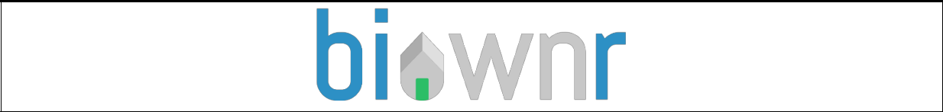

Contract of Sale Agreement - Auction

Please ensure that you download, complete and attach this “Auction –Purchase Agreement” contract to your email

I / We agree to enter a formal Contract of Sale with the Vendor in the form approved by Consumer Affairs Victoria or REIV to complete the Purchase/Sale of this property through our Legal Representative or Conveyancer.

I / We : (Name of Purchaser)

Of : (Address)

On: (Date)

Auction Purchase price for the amount of : $

Deposit Amount of : $

To be Payable by:

(Payable on Seller signing the Contract of Sale)

With the Residual Payment due at Settlement of : $

This offer will lapse unless accepted within [ N/A for properties purchased at auction ] clear

business days. (3 clear business days if none specified).

For the purchase of the property at :

Special Conditions & Terms contract (general condition 23)

If the contract is subject to 'special conditions' or ‘Terms’ then enter the particulars of the special conditions below:

Subject to the following Terms and Special Conditions: ( If applicable)

- This does NOT apply to the purchase of property at Auction

Loan (general condition 14)

The following details apply if this contract is subject to a loan being approved: (Offers subject to loan approval only apply to Buy Now OR Passed In properties)

If one of the conditions is subject to Loan Approval, please complete the details below:

Lender: This does NOT apply to the purchase of property at Auction

Loan Amount $

Approval Date:

Particulars of Sale

These details will be required to be completed upon successfully selling / purchasing a property via our online auction platform. Once both parties have signed, both parties will have all the relevant details to complete the sale of the property through your Conveyancer or Legal Practitioner )

Vendors Legal Practitioner or Conveyancer

Name/ Company Name:

Telephone:

Email:

Purchaser’s Legal Practitioner or Conveyancer

Name/ Company Name:

Telephone:

Email:

Signed by the purchaser/s :

on: (date)

Signed by the Vendor/s :

on: (date)

- I acknowledge that Biownr and all parties concerned regarding this offer will accept this communication as containing my signature for the purpose of the Electronic Transactions (Victoria ) Act 2000.

If you do not wish to sign this document with and electronic signature, please print, complete and attach this contract to your email titled “ Contract of Sale Agreement”.

A Contract of Sale template approved by Consumer Affairs Victoria complete with all the full terms and conditions is available on the Biownr website (Main Menu drop down tab).

Please feel free to download and read all the terms and conditions carefully and seek independent advice from your legal practitioner or conveyancer BEFORE you sign anything.

Cooling -off periods do not apply for properties bought at auction.

This contract agreement is a declaration, that you are the SUCCESSFUL HIGHEST BIDDER at auction for the property mentioned above and are committed to Purchase the property offline through a legal representative or conveyancer.

Both parties agree to proceed with the sale of the property through a Conveyancer or Legal Practitioner and proceed to sign the Contract of Sale at the agreed price won at auction or alternatively as per the Contract of Sale Agreement. (if further negotiations occurred with the highest bidder if property had not reached the reserve price).

I understand and acknowledge that I have received and sighted the Vendor Statement -Section 32 and that I am satisfied with the information provided.

A complete Contract of Sale will be forwarded to you by the Vendor’s Conveyancer/Legal Practitioner. This will be required to be signed by you within a reasonable time period (generally within 5 business days).Auction

Deposit Payment

Deposit payment mentioned above is generally 10% of the purchase price which will be paid to the Seller’s Solicitor / Conveyancer’s Statutory Trust Account once the official Contract of Sale has been signed.

We simply request that once both parties have signed, you kindly submit to our office the formal Contract of Sale Agreement within a reasonable time after the date of Auction. ( Reasonable time, is generally 1-2 days after the date of Auction – unless alternative arrangements have been made. Please email us at support@biownr.com.au as we must notify all the third party real estate websites that the property has been sold.

Please ensure that upon receiving the Contract of Sale from the Vendor’s Conveyancer, you seek professional legal advice by engaging an independent Conveyancer/Legal Practitioner to ensure that you understand all the terms and conditions stipulated in the contract PRIOR to your signing.

